Shivam Taneja

Class x – e |  The Shri Ram School – Aravali, Gurugram

Computer applications

BOard project

(2017 – 2018)

**(^_^)Welcome to Holiday Homework Cinemas! (^_^)**

**INDEX**

**1.Acknowlegdment**

**2.Logic Description**

**3.Output Window(Screenshots)**

**4.Source Code**

**5.List of Variables**

**6.Bibliography**

**Acknowledgment**

**I would like to this oppurtunity to thank Alka Ma’am, our Computer Applications teacher for helping me debug my program. A simple correction made by her saved my entire program!**

**Next I would like to thank the developers of NetBeans, without this software, locating small-small mistakes and developing the program in the first place would not have been possible. Lastly, I would like to thank the random users at stackoverflow for helping me out with new concepts in programming and some YouTube channels for helping me out with the execution of my program.**

**Logic Description**

**The program is a menu driven program, so I have used switch case.**

**For displaying the current ‘Now Showing’ movies I have used FOR loop.**

**I have used if- else statements to check whether the Username and password entered are right or wrong, I have used if-else to prevent printing of NULL values. I have used if-else to check whether the no. of seats input does not exceed the no. of seats available and I have also used if-else to check whether the date entered for the movie is valid or not. I have created a separate class to print the seating arrangement of the the Audi, main method and for the payment system. In my payment class, I have given the user the ways to pay to make the program more flexible.**

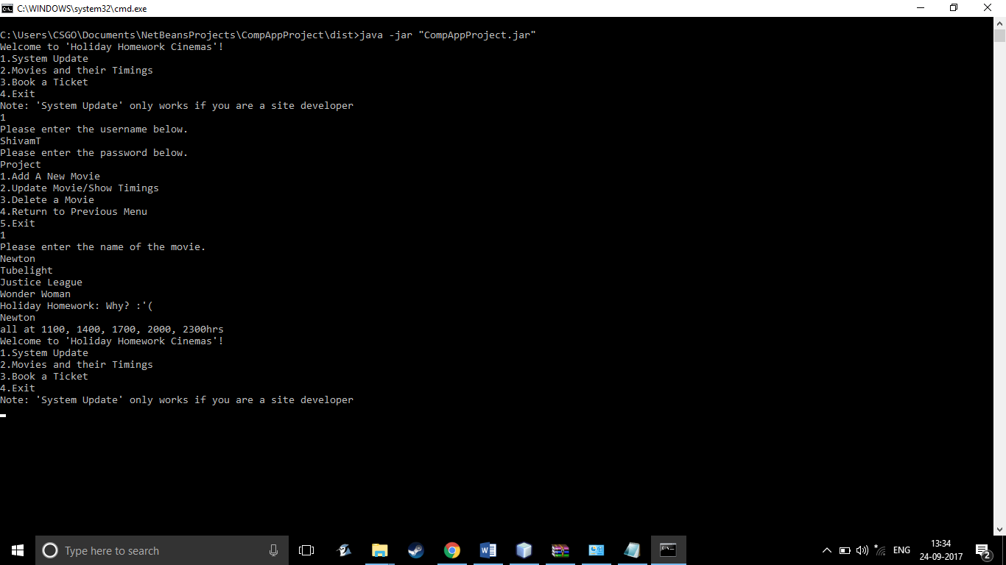**OUTPUT WINDOW**

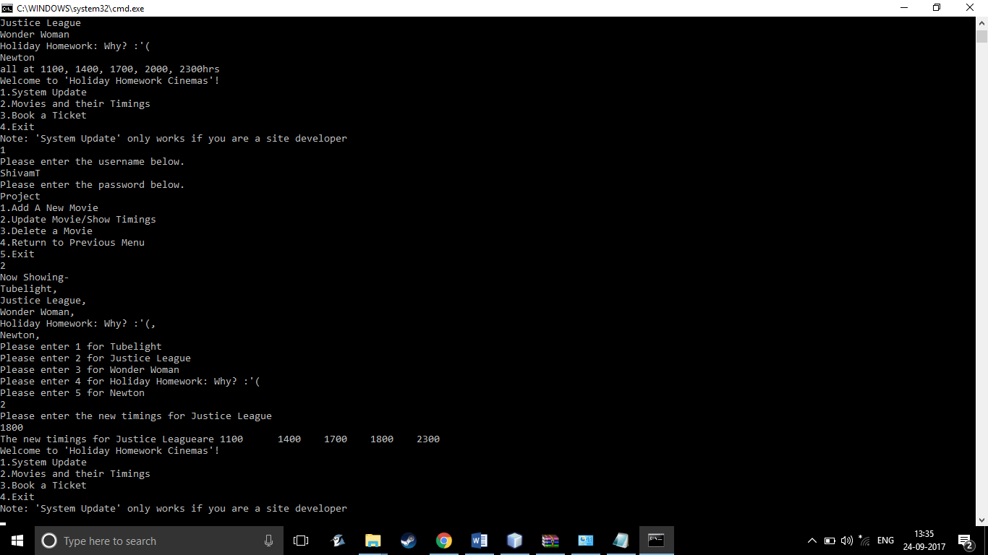

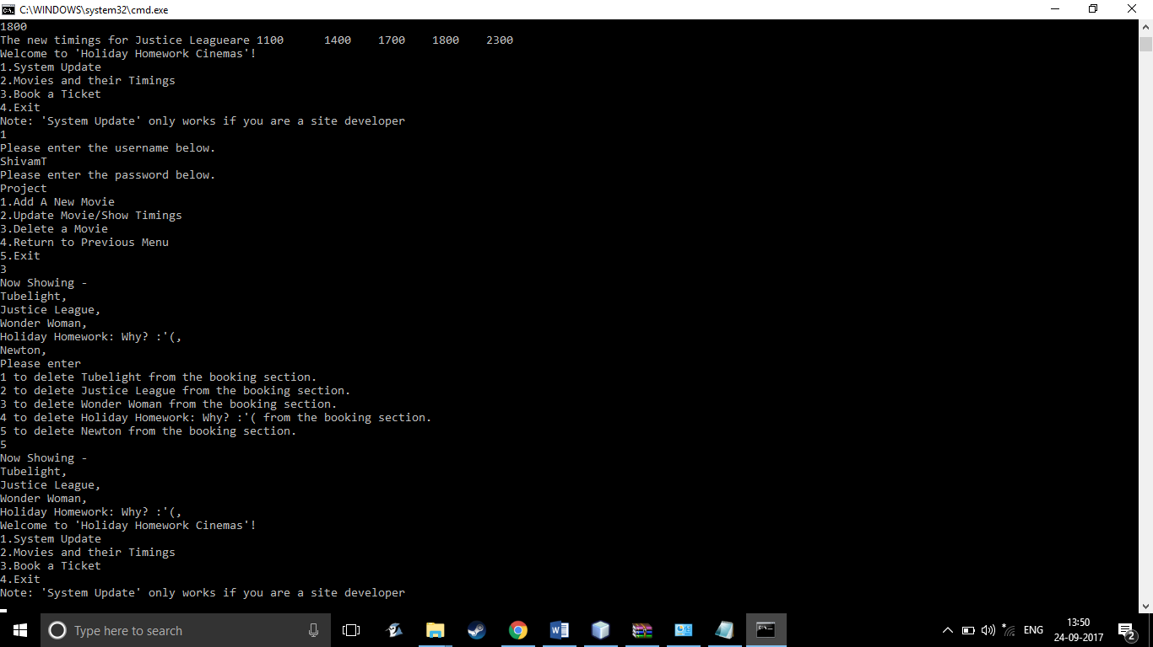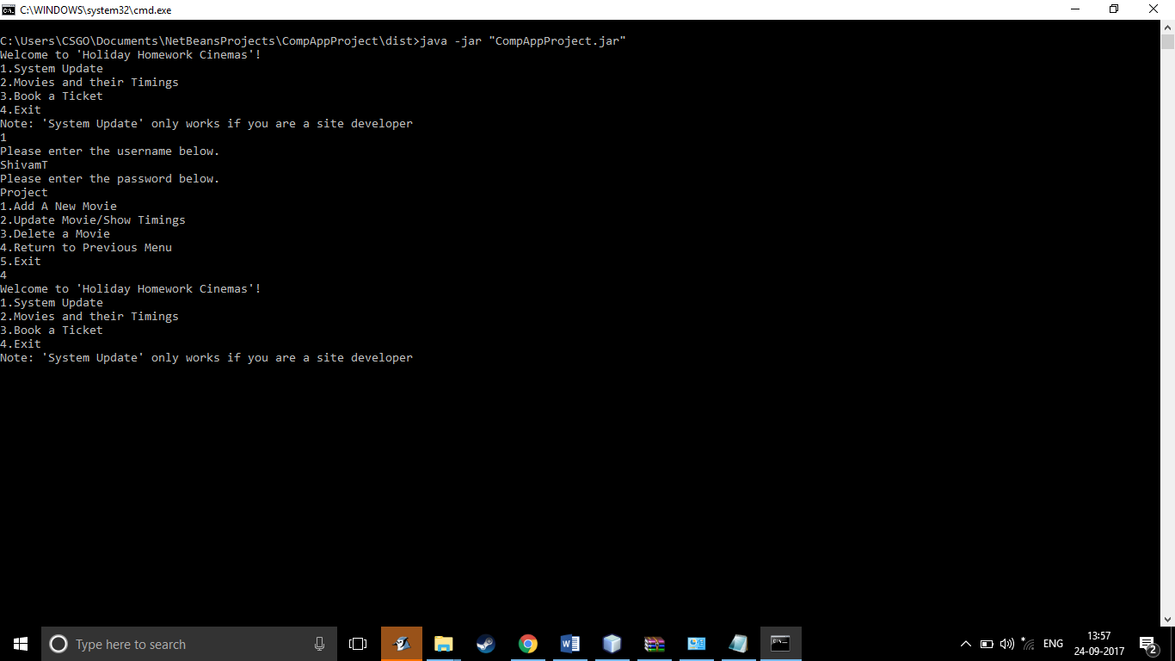



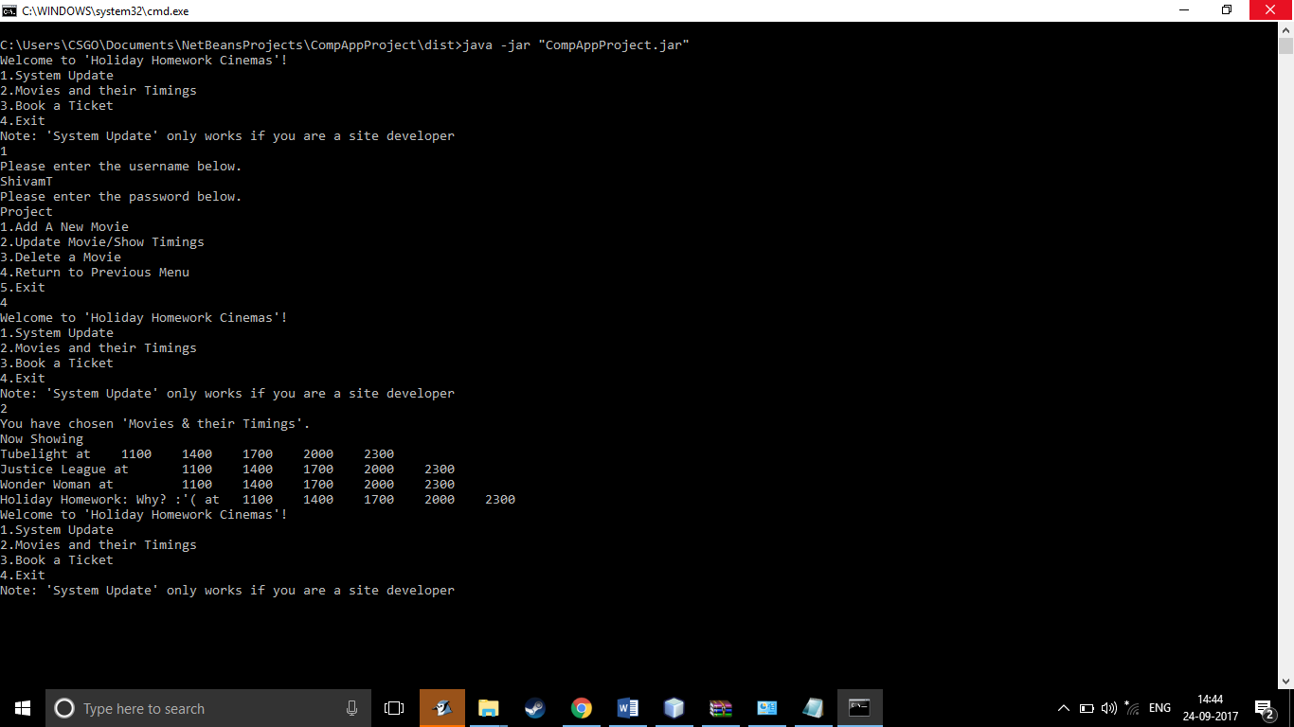

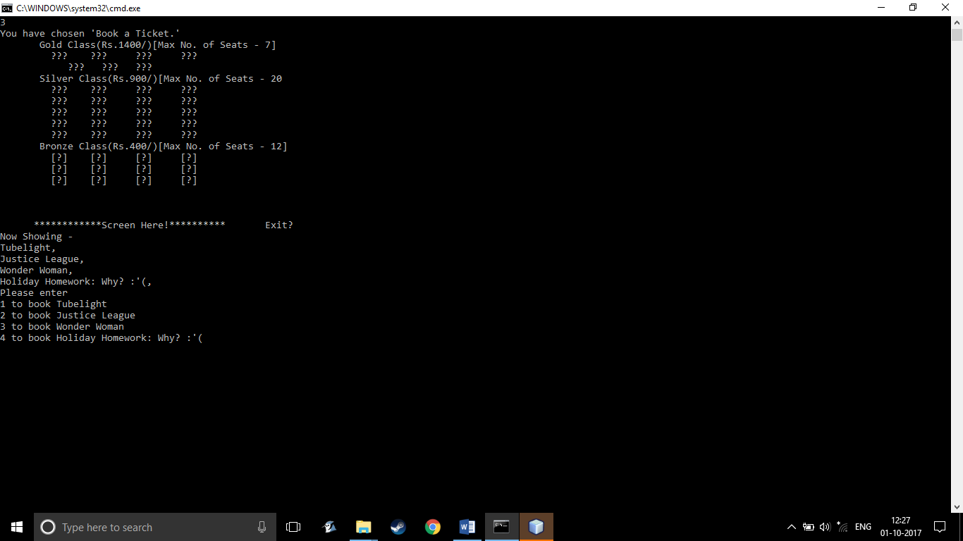  
**CMD WINDOW**

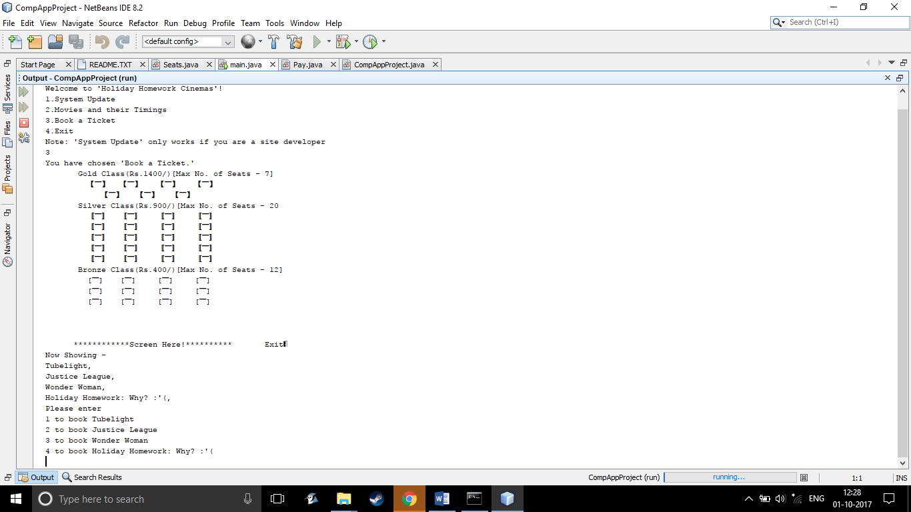

**ORIGINAL WINDOW**

4

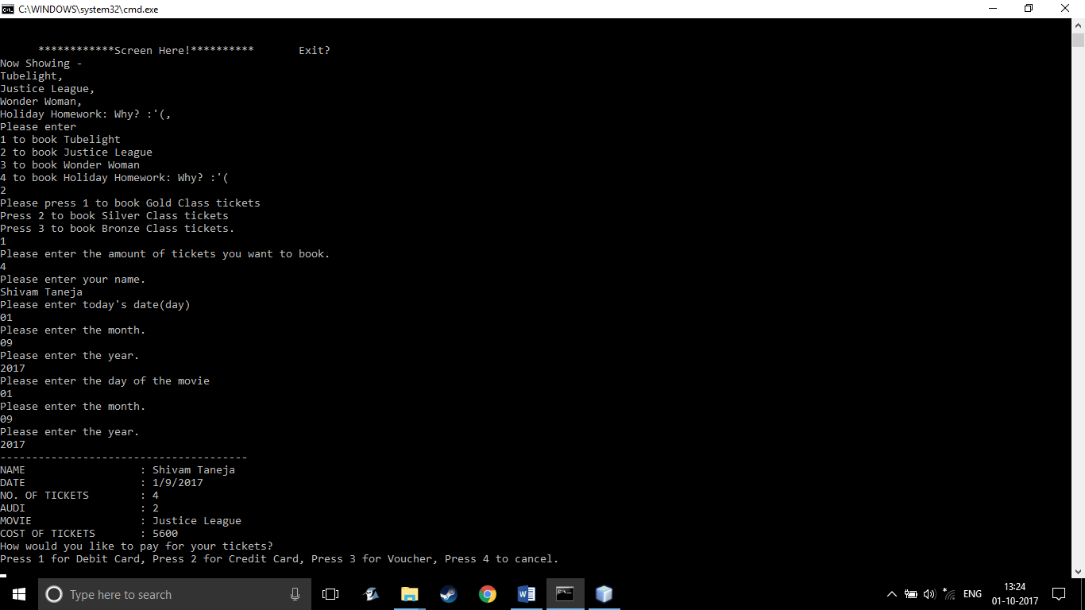

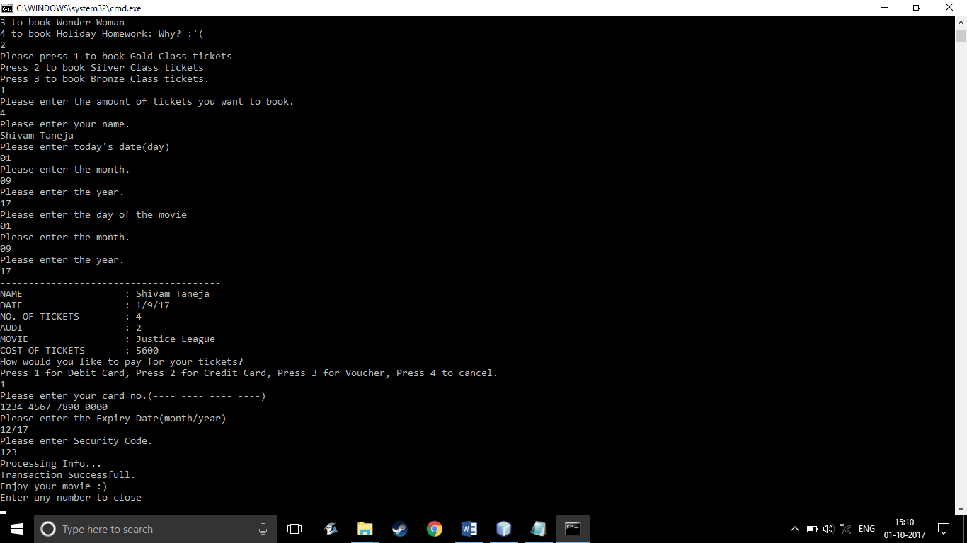



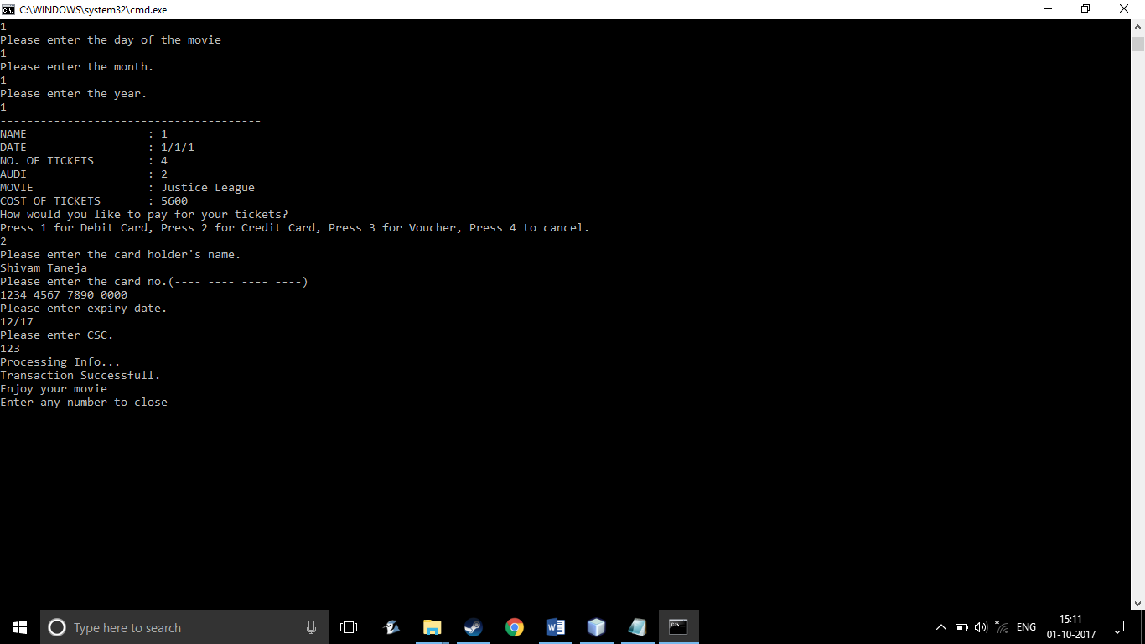

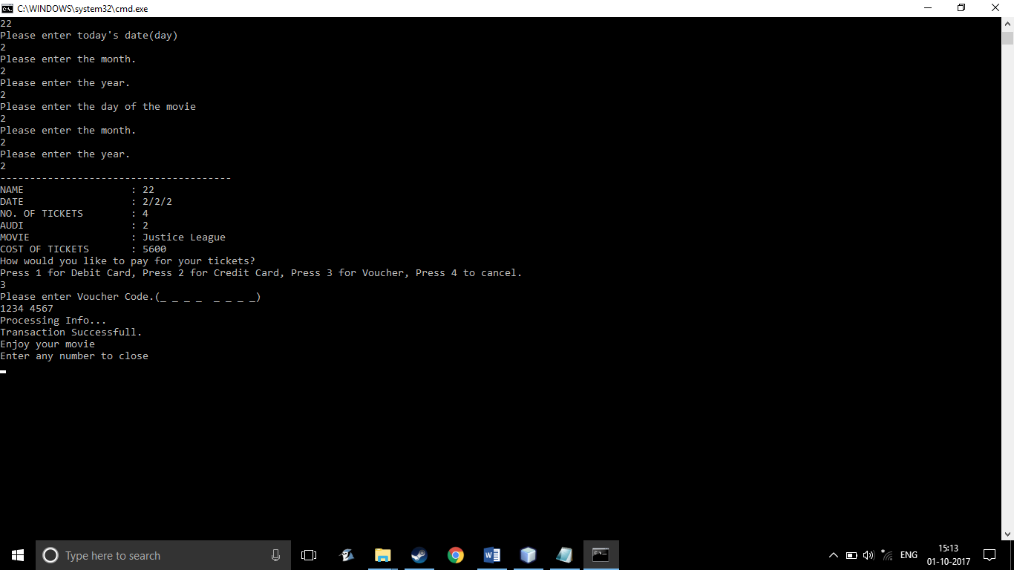

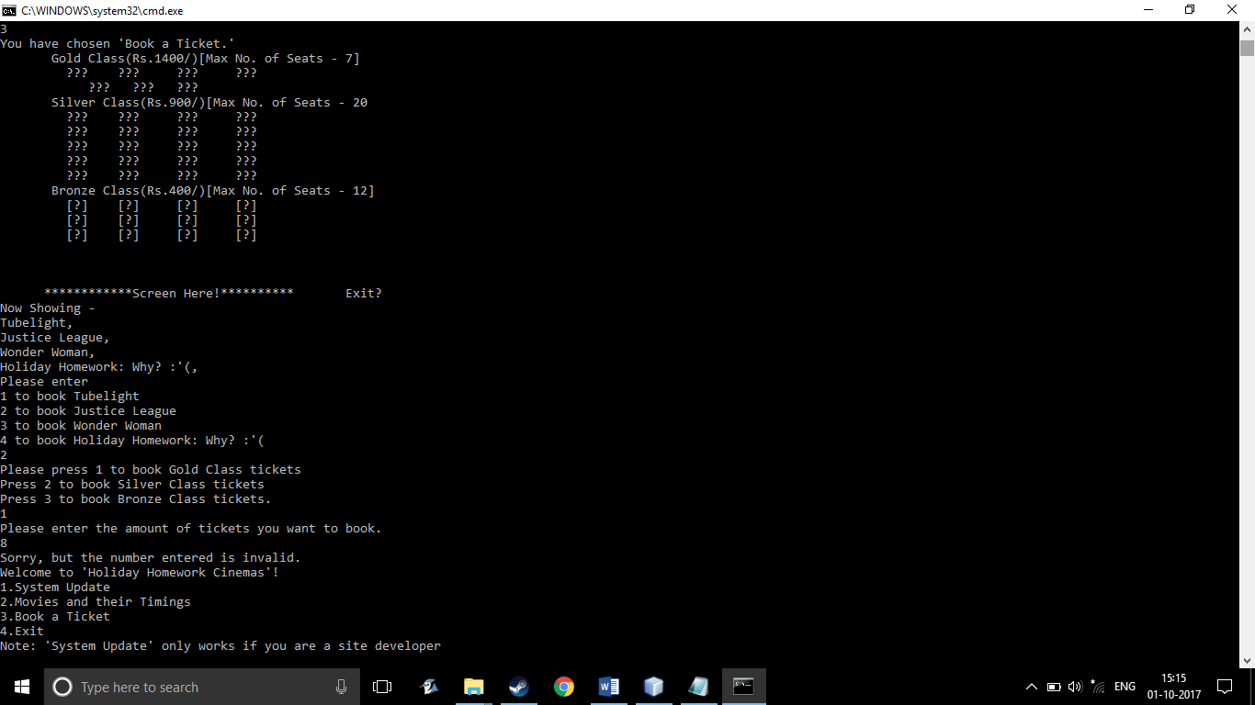

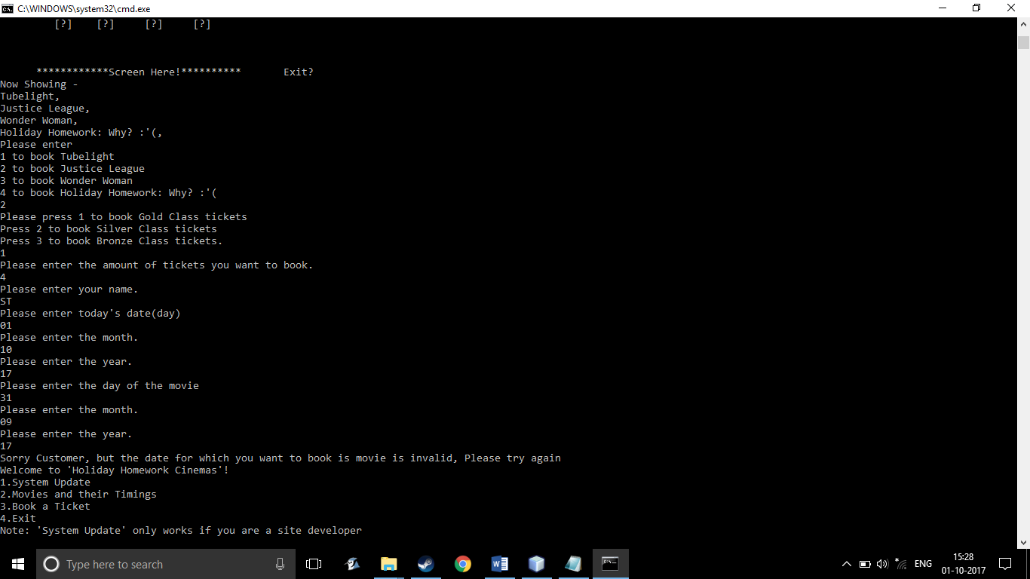

**Source Code**

**import java.util.Scanner;**

**/\***

**\* Code for payment options**

**\*/**

**/\*\***

**\***

**\* @author Shivam Taneja**

**\*/**

**public class Pay**

**{**

**public void payment()**

**{**

**Scanner Sc = new Scanner(System.in);**

**System.out.println("How would you like to pay for your tickets?");**

**System.out.println("Press 1 for Debit Card, Press 2 for Credit Card, Press 3 for Voucher, Press 4 to cancel.");**

**int choose = Sc.nextInt();**

**switch(choose)**

**{**

**case 1:**

**{**

**System.out.println("Please enter your card no.(---- ---- ---- ----)");**

**String card_no = Sc.nextLine();**

**card_no = Sc.nextLine();**

**System.out.println("Please enter the Expiry Date(month/year)");**

**String exp_date = Sc.nextLine();**

**System.out.println("Please enter Security Code.");**

**int sec_code = Sc.nextInt();**

**System.out.println("Processing Info...");**

**System.out.println("Transaction Successfull.");**

**System.out.println("Enjoy your movie :)");**

**System.out.println("Enter any number to close");**

**int xxxxxx = Sc.nextInt();**

**break;**

**}**

**case 2:**

**{**

**System.out.println("Please enter the card holder's name.");**

**String name = Sc.nextLine();**

**name = Sc.nextLine();**

**System.out.println("Please enter the card no.(---- ---- ---- ----)");**

**String card_no = Sc.nextLine();**

**System.out.println("Please enter expiry date.");**

**String exp_date = Sc.nextLine();**

**System.out.println("Please enter CSC.");**

**int sec_code = Sc.nextInt();**

**System.out.println("Processing Info...");**

**System.out.println("Transaction Successfull.");**

**System.out.println("Enjoy your movie ");**

**System.out.println("Enter any number to close");**

**int xxxxxx = Sc.nextInt();**

**break;**

**}**

**case 3:**

**{**

**System.out.println("Please enter Voucher Code.(_ _ _ _ _ _ _ _)");**

**String vouch = Sc.nextLine();**

**vouch = Sc.nextLine();**

**System.out.println("Processing Info...");**

**System.out.println("Transaction Successfull.");**

**System.out.println("Enjoy your movie ");**

**System.out.println("Enter any number to close");**

**int xxxxxx = Sc.nextInt();**

**break;**

**}**

**case 4:**

**System.out.print('\u000C');**

**break;**

**}**

**}**

**}**

**/\***

**\* Code to Display the Seating Arrangement of the hall.**

**\*/**

**/\*\***

**\***

**\* @author Shivam Taneja**

**\*/**

**public class Seats**

**{**

**void seatsdisplay()**

**{**

**System.out.print(" Gold Class(Rs.1400/)[Max No. of Seats - 7]");**

**System.out.println('\n' + " 【▔】" + '\t' + "【▔】" + '\t' + "【▔】" + '\t' + "【▔】" + '\n' + " 【▔】" + " 【▔】" + " 【▔】");**

**System.out.println(" Silver Class(Rs.900/)[Max No. of Seats - 20");**

**System.out.println( " 〚▔〛" + '\t' + "〚▔〛" + '\t' + "〚▔〛" + '\t' + "〚▔〛" + '\n' + " 〚▔〛" + '\t' + "〚▔〛" + '\t' + "〚▔〛" + '\t' + "〚▔〛" + '\n' + " 〚▔〛" + '\t' + "〚▔〛" + '\t' + "〚▔〛" + '\t' + "〚▔〛" + '\n' + " 〚▔〛" + '\t' + "〚▔〛" + '\t' + "〚▔〛" + '\t' + "〚▔〛" + '\n' + " 〚▔〛" + '\t' + "〚▔〛" + '\t' + "〚▔〛" + '\t' + "〚▔〛");**

**System.out.println(" Bronze Class(Rs.400/)[Max No. of Seats - 12]");**

**System.out.println(" [▔]" + '\t' + "[▔]" + '\t' + "[▔]" + '\t' + "[▔]" + '\n'+ " [▔]" + '\t' + "[▔]" + '\t' + "[▔]" + '\t' + "[▔]" + '\n' + " [▔]" + '\t' + "[▔]" + '\t' + "[▔]" + '\t' + "[▔]");**

**System.out.println(" " + '\n' + " " + '\n' + " ");**

**System.out.println(" ************Screen Here!********** Exit🚪");**

**}**

**}**

**Main Code**

**import java.util.*;**

**/\*\***

**\* This is a program that helps the site developers update the site.**

**\* Helps a user see the list of movies and book a movie.**

**\* Book a ticket.**

**\* Exit the program**

**\* @author (Shivam Taneja)**

**\* @version (20.06.17.9.08.17)**

**\*/**

**public class CompAppProject**

**{//class starts**

**int screen_1 = 1;**

**int screen_2_1 = 2;**

**static String arr_mov[] = new String[6];**

**int timing_mov2[]= new int [6];**

**int timing_mov3[] = new int [6];**

**int timing_mov4[] = new int [6];**

**int timing_mov5[] = new int [6];**

**int timing_mov6[] = new int [6];**

**int timing_mov1[] = new int [6];**

**@SuppressWarnings("empty-statement")**

**void display()**

**{//main method begins**

**Scanner Sc = new Scanner(System.in);**

**System.out.println("Welcome to 'Holiday Homework Cinemas'!");**

**System.out.println("1.System Update" + '\n' + "2.Movies and their Timings" + '\n' + "3.Book a Ticket" + '\n' + "4.Exit");**

**System.out.println("Note: 'System Update' only works if you are a site developer");**

**screen_1 = Sc.nextInt();**

**Sc.nextLine();**

**int gold_tickets = 7;**

**int silver_tickets = 20;**

**int bronze_tickets = 12;**

**arr_mov[0]= "Tubelight";**

**arr_mov[1]= "Justice League";**

**arr_mov[2]= "Wonder Woman";**

**arr_mov[3]= "Holiday Homework: Why? :'(";**

**timing_mov1[0] = 1100;**

**timing_mov1[1] = 1400;**

**timing_mov1[2] = 1700;**

**timing_mov1[3] = 2000;**

**timing_mov1[4] = 2300;**

**CompAppProject show;//object to recall display method.**

**show = new CompAppProject();**

**for(int i = 0; i < 5; i ++)**

**{**

**timing_mov2[i] = timing_mov1[i];**

**timing_mov3[i] = timing_mov1[i];**

**timing_mov4[i] = timing_mov1[i];**

**timing_mov5[i] = timing_mov1[i];**

**timing_mov6[i] = timing_mov1[i];**

**}**

**switch(screen_1)**

**{//screen 1 dislpay 1**

**case 1 :**

**{**

**System.out.println("Please enter the username below.");**

**String userid = Sc.next();**

**Sc.nextLine();**

**System.out.println("Please enter the password below.");**

**String password = Sc.next();**

**Sc.nextLine();**

**if(userid .equals("ShivamT") && password .equals("Project"))**

**{**

**System.out.println("1.Add A New Movie" + '\n' + "2.Update Movie/Show Timings" + '\n' + "3.Delete a Movie" + '\n' + "4.Return to Previous Menu" + '\n' + "5.Exit");**

**int n = Sc.nextInt();**

**Sc.nextLine();**

**screen_2_1=n;**

**switch(screen_2_1)**

**{//screen 2 display 1**

**case 1:**

**{**

**System.out.println("Please enter the name of the movie.");**

**arr_mov[4] = Sc.nextLine();**

**System.out.println(arr_mov[0] + '\n' + arr_mov[1] + '\n' + arr_mov[2] + '\n' + arr_mov[3] + '\n' + arr_mov[4] + '\n' + "all at 1100, 1400, 1700, 2000, 2300hrs");**

**show.display();**

**break;**

**}**

**case 2:**

**{**

**System.out.println("Now Showing-" );**

**for(int l = 0; l < 6; l++)**

**{**

**if(arr_mov[l] == null)**

**{**

**;**

**}**

**else**

**{**

**System.out.println(arr_mov[l] + ", ");**

**}**

**}**

**for(int i = 0; i< 6; i++)**

**{**

**if(arr_mov[i] == null)**

**{**

**;**

**}**

**else**

**{**

**System.out.println( "Please enter " + (i+1) + " for " + arr_mov[i]);**

**}**

**}**

**int ans = Sc.nextInt();**

**Sc.nextLine();**

**switch(ans)**

**{**

**case 1:**

**{**

**System.out.println("Please enter the new timings for " + arr_mov[0] + '\n' + "Please note that there are no shows after 2300.");**

**timing_mov1[5] = Sc.nextInt();**

**Sc.nextLine();**

**for(int i = 0; i < 5;i++)**

**{**

**if(timing_mov1[i] > timing_mov1[5])**

**{**

**timing_mov1[i] = timing_mov1[5];**

**break;**

**}**

**else**

**{**

**;**

**}**

**}**

**System.out.println("The new timings for " + arr_mov[0] + "are " + timing_mov1[0] + '\t' + timing_mov1[1] + '\t' + timing_mov1[2] + '\t' + timing_mov1[3] + '\t' + timing_mov1[4]);**

**break;**

**}**

**case 2:**

**{**

**System.out.println("Please enter the new timings for " + arr_mov[1]);**

**timing_mov2[5] = Sc.nextInt();**

**Sc.nextLine();**

**for(int i = 0; i < 5;i++)**

**{**

**if(timing_mov2[i] > timing_mov2[5])**

**{**

**timing_mov2[i] = timing_mov2[5];**

**break;**

**}**

**else**

**{**

**;**

**}**

**}**

**System.out.println("The new timings for " + arr_mov[1] + "are " + timing_mov2[0] + '\t' + timing_mov2[1] + '\t' + timing_mov2[2] + '\t' + timing_mov2[3] + '\t' + timing_mov2[4]);**

**break;**

**}**

**case 3:**

**{**

**System.out.println("Please enter the new timings for " + arr_mov[2]);**

**timing_mov3[5] = Sc.nextInt();**

**Sc.nextLine();**

**for(int i = 0; i < 5;i++)**

**{**

**if(timing_mov3[i] > timing_mov3[5])**

**{**

**timing_mov3[i] = timing_mov3[5];**

**break;**

**}**

**else**

**{**

**;**

**}**

**}**

**System.out.println("The new timings for " + arr_mov[2] + "are " + timing_mov3[0] + '\t' + timing_mov3[1] + '\t' + timing_mov3[2] + '\t' + timing_mov3[3] + '\t' + timing_mov3[4]);**

**break;**

**}**

**case 4:**

**{**

**System.out.println("Please enter the new timings for " + arr_mov[3]);**

**timing_mov4[5] = Sc.nextInt();**

**Sc.nextLine();**

**for(int i = 0; i < 5;i++)**

**{**

**if(timing_mov4[i] > timing_mov4[5])**

**{**

**timing_mov4[i] = timing_mov4[5];**

**break;**

**}**

**else**

**{**

**;**

**}**

**}**

**System.out.println("The new timings for " + arr_mov[3] + "are " + timing_mov4[0] + '\t' + timing_mov4[1] + '\t' + timing_mov4[2] + '\t' + timing_mov4[3] + '\t' + timing_mov4[4]);**

**break;**

**}**

**case 5:**

**{**

**System.out.println("Please enter the new timings for " + arr_mov[4]);**

**timing_mov5[5] = Sc.nextInt();**

**Sc.nextLine();**

**for(int i = 0; i < 5;i++)**

**{**

**if(timing_mov5[i] > timing_mov5[5])**

**{**

**timing_mov5[i] = timing_mov5[5];**

**break;**

**}**

**else**

**{**

**;**

**}**

**}**

**System.out.println("The new timings for " + arr_mov[4] + "are " + timing_mov5[0] + '\t' + timing_mov5[1] + '\t' + timing_mov5[2] + '\t' + timing_mov5[3] + '\t' + timing_mov5[4]);**

**break;**

**}**

**case 6:**

**{**

**System.out.println("Please enter the new timings for " + arr_mov[5]);**

**timing_mov6[5] = Sc.nextInt();**

**Sc.nextLine();**

**for(int i = 0; i < 5;i++)**

**{**

**if(timing_mov6[i] > timing_mov6[5])**

**{**

**timing_mov6[i] = timing_mov6[5];**

**break;**

**}**

**else**

**{**

**;**

**}**

**}**

**System.out.println("The new timings for " + arr_mov[5] + " are " + '\t' + timing_mov6[0] + '\t' + timing_mov6[1] + '\t' + timing_mov6[2] + '\t' + timing_mov6[3] + timing_mov6[4]);**

**break;**

**}**

**}**

**show.display();**

**break;**

**}**

**case 3:**

**{**

**System.out.println("Now Showing -");**

**for(int l = 0; l < 6; l++)**

**{**

**if(arr_mov[l] == null)**

**{**

**;**

**}**

**else**

**{**

**System.out.println(arr_mov[l] + ", ");**

**}**

**}**

**System.out.println("Please enter");**

**for(int i = 0; i< 6; i++)**

**{**

**if(arr_mov[i] == null)**

**{**

**;**

**}**

**else**

**{**

**System.out.println((i+1) + " to delete " + arr_mov[i] + " from the booking section.");**

**}**

**}**

**int inp = Sc.nextInt();**

**Sc.nextLine();**

**switch(inp)**

**{**

**case 1:**

**{**

**arr_mov[0] = null;**

**System.out.println("Now Showing -");**

**for(int l = 0; l < 6; l++)**

**{**

**if(arr_mov[l] == null)**

**{**

**;**

**}**

**else**

**{**

**System.out.println(arr_mov[l] + ", ");**

**}**

**}**

**break;**

**}**

**case 2:**

**{**

**arr_mov[1]=null;**

**System.out.println("Now Showing -");**

**for(int l = 0; l < 6; l++)**

**{**

**if(arr_mov[l] == null)**

**{**

**;**

**}**

**else**

**{**

**System.out.println(arr_mov[l] + ", ");**

**}**

**}**

**break;**

**}**

**case 3:**

**{**

**arr_mov[2] = null;**

**System.out.println("Now Showing -");**

**for(int l = 0; l < 6; l++)**

**{**

**if(arr_mov[l] == null)**

**{**

**;**

**}**

**else**

**{**

**System.out.println(arr_mov[l] + ", ");**

**}**

**}**

**break;**

**}**

**case 4:**

**{**

**arr_mov[3] = null;**

**System.out.println("Now Showing -");**

**for(int l = 0; l < 6; l++)**

**{**

**if(arr_mov[l] == null)**

**{**

**;**

**}**

**else**

**{**

**System.out.println(arr_mov[l] + ", ");**

**}**

**}**

**break;**

**}**

**case 5:**

**{**

**arr_mov[4] = null;**

**System.out.println("Now Showing -");**

**for(int l = 0; l < 6; l++)**

**{**

**if(arr_mov[l] == null)**

**{**

**;**

**}**

**else**

**{**

**System.out.println(arr_mov[l] + ", ");**

**}**

**}**

**break;**

**}**

**case 6:**

**{**

**arr_mov[5] = null;**

**System.out.println("Now Showing -");**

**for(int l = 0; l < 6; l++)**

**{**

**if(arr_mov[l] == null )**

**{**

**;**

**}**

**else**

**{**

**System.out.println(arr_mov[l] + ", ");**

**}**

**}**

**break;**

**}**

**}**

**show.display();**

**break;**

**}**

**case 4:**

**{**

**show.display();**

**break;**

**}**

**case 5:**

**{**

**System.out.print('\u000C');**

**break;**

**}**

**}**

**}**

**else**

**{**

**System.out.println("Wrong username or password, please try again.");**

**show.display();**

**}**

**break;**

**}**

**case 2:**

**{**

**System.out.println("You have chosen 'Movies & their Timings'.");**

**System.out.println("Now Showing");**

**if(arr_mov[0] ==null )**

**{**

**;**

**}**

**else**

**{**

**System.out.println(arr_mov[0] + " at " + '\t' + timing_mov1[0] + '\t' + timing_mov1[1] + '\t' + timing_mov1[2] + '\t' + timing_mov1[3] + '\t' + timing_mov1[4]);**

**}**

**if(arr_mov[1] ==null )**

**{**

**;**

**}**

**else**

**{**

**System.out.println(arr_mov[1] + " at " +'\t' + timing_mov2[0] + '\t' + timing_mov2[1] + '\t' + timing_mov2[2] + '\t' + timing_mov2[3] + '\t' + timing_mov2[4]);**

**}**

**if(arr_mov[2] ==null )**

**{**

**;**

**}**

**else**

**{**

**System.out.println(arr_mov[2] + " at " + '\t' + timing_mov3[0] + '\t' + timing_mov3[1] + '\t' + timing_mov3[2] + '\t' + timing_mov3[3] + '\t' + timing_mov3[4]);**

**}**

**if(arr_mov[3] ==null )**

**{**

**;**

**}**

**else**

**{**

**System.out.println(arr_mov[3] + " at " + '\t' + timing_mov4[0] + '\t' + timing_mov4[1] + '\t' + timing_mov4[2] + '\t' + timing_mov4[3] + '\t' + timing_mov4[4]);**

**}**

**if(arr_mov[4]==null )**

**{**

**;**

**}**

**else**

**{**

**System.out.println(arr_mov[4] + " at " + '\t' + timing_mov5[0] + '\t' + timing_mov5[1] + '\t' + timing_mov5[2] + '\t' + timing_mov5[3] + '\t' + timing_mov5[4]);**

**}**

**if(arr_mov[5] ==null )**

**{**

**;**

**}**

**else**

**{**

**System.out.println(arr_mov[5] + " at " + '\t' + timing_mov6[0] + '\t' + timing_mov6[1] + '\t' + timing_mov6[2] + '\t' + timing_mov6[3] + '\t' + timing_mov6[4]);**

**}**

**show.display();**

**break;**

**}**

**case 3:**

**{**

**System.out.println("You have chosen 'Book a Ticket.'");**

**Pay paym = new Pay();**

**Seats seat = new Seats();**

**seat.seatsdisplay();**

**System.out.println("Now Showing -");**

**for(int l = 0; l < 6; l++)**

**{**

**if(arr_mov[l] ==null)**

**{**

**;**

**}**

**else**

**{**

**System.out.println(arr_mov[l] + ", ");**

**}**

**}**

**System.out.println("Please enter");**

**for(int i = 0; i< 6; i++)**

**{**

**if(arr_mov[i] ==null)**

**{**

**;**

**}**

**else**

**{**

**System.out.println((i+1) + " to book " + arr_mov[i]);**

**}**

**}**

**int choice = Sc.nextInt();**

**Sc.nextLine();**

**switch(choice)**

**{**

**case 1:**

**{**

**System.out.println("Please press 1 to book Gold Class tickets" + '\n' + "Press 2 to book Silver Class tickets" + '\n' + "Press 3 to book Bronze Class tickets.");**

**int choose = Sc.nextInt();**

**Sc.nextLine();**

**switch(choose)**

**{**

**case 1:**

**{**

**System.out.println("Please enter the amount of tickets you want to book.");**

**int inp_gold = Sc.nextInt();**

**Sc.nextLine();**

**if(inp_gold <= gold_tickets)**

**{**

**int temp = gold_tickets - inp_gold;**

**gold_tickets = temp;**

**System.out.println("Please enter your name.");**

**String name = Sc.nextLine();**

**System.out.println("Please enter today's date(day)");**

**int date_d = Sc.nextInt();**

**Sc.nextLine();**

**System.out.println("Please enter the month.");**

**int date_m = Sc.nextInt();**

**Sc.nextLine();**

**System.out.println("Please enter the year.");**

**int date_y = Sc.nextInt();**

**Sc.nextLine();**

**System.out.println("Please enter the day of the movie");**

**int m_date_d = Sc.nextInt();**

**Sc.nextLine();**

**System.out.println("Please enter the month.");**

**int m_date_m = Sc.nextInt();**

**Sc.nextLine();**

**System.out.println("Please enter the year.");**

**int m_date_y = Sc.nextInt();**

**Sc.nextLine();**

**if(m_date_d >= date_d && m_date_m >= date_m && m_date_y >= date_y)**

**{**

**System.out.println("---------------------------------------");**

**System.out.println("NAME : " + name);**

**System.out.println("DATE : " + m_date_d + "/" + m_date_m + "/" + m_date_y);**

**System.out.println("NO. OF TICKETS : " + inp_gold);**

**System.out.println("AUDI : " + choice );**

**System.out.println("MOVIE : " + arr_mov[0]);**

**System.out.println("COST OF TICKETS : " + (inp_gold * 1400));**

**break;**

**}**

**else**

**{**

**System.out.println("Sorry Customer, but the date for which you want to book is movie is invalid, Please try again");**

**show.display();**

**break;**

**}**

**}**

**else**

**{**

**System.out.println("Sorry, but the number entered is invalid.");**

**show.display();**

**break;**

**}**

**}**

**case 2:**

**{**

**System.out.println("Please enter the amount of tickets you want to book.");**

**int inp_silver = Sc.nextInt();**

**Sc.nextLine();**

**if(inp_silver <= silver_tickets)**

**{**

**int temp = silver_tickets - inp_silver;**

**gold_tickets = temp;**

**System.out.println("Please enter your name.");**

**String name = Sc.nextLine();**

**System.out.println("Please enter today's date(day)");**

**int date_d = Sc.nextInt();**

**Sc.nextLine();**

**System.out.println("Please enter the month.");**

**int date_m = Sc.nextInt();**

**Sc.nextLine();**

**System.out.println("Please enter the year.");**

**int date_y = Sc.nextInt();**

**Sc.nextLine();**

**System.out.println("Please enter the day of the movie");**

**int m_date_d = Sc.nextInt();**

**Sc.nextLine();**

**System.out.println("Please enter the month.");**

**int m_date_m = Sc.nextInt();**

**Sc.nextLine();**

**System.out.println("Please enter the year.");**

**int m_date_y = Sc.nextInt();**

**Sc.nextLine();**

**if(m_date_d >= date_d && m_date_m >= date_m && m_date_y >= date_y)**

**{**

**System.out.println("---------------------------------------");**

**System.out.println("NAME : " + name);**

**System.out.println("DATE : " + m_date_d + "/" + m_date_m + "/" + m_date_y);**

**System.out.println("NO. OF TICKETS : " + inp_silver);**

**System.out.println("AUDI : " + choice );**

**System.out.println("MOVIE : " + arr_mov[0]);**

**System.out.println("COST OF TICKETS : " + (inp_silver * 900));**

**}**

**else**

**{**

**System.out.println("Sorry Customer, but the date for which you want to book is movie is invalid, Please try again");**

**show.display();**

**break;**

**}**

**}**

**else**

**{**

**System.out.println("Sorry, but the number entered is invalid.");**

**show.display();**

**break;**

**}**

**}**

**case 3 :**

**{**

**System.out.println("Please enter the amount of tickets you want to book.");**

**int inp_bronze = Sc.nextInt();**

**Sc.nextLine();**

**if(inp_bronze <= bronze_tickets)**

**{**

**int temp = bronze_tickets - inp_bronze;**

**bronze_tickets = temp;**

**System.out.println("Please enter your name.");**

**String name = Sc.nextLine();**

**System.out.println("Please enter today's date(day)");**

**int date_d = Sc.nextInt();**

**Sc.nextLine();**

**System.out.println("Please enter the month.");**

**int date_m = Sc.nextInt();**

**Sc.nextLine();**

**System.out.println("Please enter the year.");**

**int date_y = Sc.nextInt();**

**Sc.nextLine();**

**System.out.println("Please enter the day of the movie");**

**int m_date_d = Sc.nextInt();**

**Sc.nextLine();**

**System.out.println("Please enter the month.");**

**int m_date_m = Sc.nextInt();**

**Sc.nextLine();**

**System.out.println("Please enter the year.");**

**int m_date_y = Sc.nextInt();**

**Sc.nextLine();**

**if(m_date_d >= date_d && m_date_m >= date_m && m_date_y >= date_y)**

**{**

**System.out.println("---------------------------------------");**

**System.out.println("NAME : " + name);**

**System.out.println("DATE : " + m_date_d + "/" + m_date_m + "/" + m_date_y);**

**System.out.println("NO. OF TICKETS : " + inp_bronze);**

**System.out.println("AUDI : " + choice );**

**System.out.println("MOVIE : " + arr_mov[0]);**

**System.out.println("COST OF TICKETS : " + (inp_bronze * 400));**

**break;**

**}**

**else**

**{**

**System.out.println("Sorry Customer, but the date for which you want to book is movie is invalid, Please try again");**

**show.display();**

**break;**

**}**

**}**

**else**

**{**

**System.out.println("Sorry, but the number entered is invalid.");**

**show.display();**

**break;**

**}**

**}**

**}**

**}**

**case 2:**

**{**

**System.out.println("Please press 1 to book Gold Class tickets" + '\n' + "Press 2 to book Silver Class tickets" + '\n' + "Press 3 to book Bronze Class tickets.");**

**int choose = Sc.nextInt();**

**Sc.nextLine();**

**switch(choose)**

**{**

**case 1:**

**{**

**System.out.println("Please enter the amount of tickets you want to book.");**

**int inp_gold = Sc.nextInt();**

**Sc.nextLine();**

**if(inp_gold <= gold_tickets)**

**{**

**int temp = gold_tickets - inp_gold;**

**gold_tickets = temp;**

**System.out.println("Please enter your name.");**

**String name = Sc.nextLine();**

**System.out.println("Please enter today's date(day)");**

**int date_d = Sc.nextInt();**

**Sc.nextLine();**

**System.out.println("Please enter the month.");**

**int date_m = Sc.nextInt();**

**Sc.nextLine();**

**System.out.println("Please enter the year.");**

**int date_y = Sc.nextInt();**

**Sc.nextLine();**

**System.out.println("Please enter the day of the movie");**

**int m_date_d = Sc.nextInt();**

**Sc.nextLine();**

**System.out.println("Please enter the month.");**

**int m_date_m = Sc.nextInt();**

**Sc.nextLine();**

**System.out.println("Please enter the year.");**

**int m_date_y = Sc.nextInt();**

**Sc.nextLine();**

**if(m_date_d >= date_d && m_date_m >= date_m && m_date_y >= date_y)**

**{**

**System.out.println("---------------------------------------");**

**System.out.println("NAME : " + name);**

**System.out.println("DATE : " + m_date_d + "/" + m_date_m + "/" + m_date_y);**

**System.out.println("NO. OF TICKETS : " + inp_gold);**

**System.out.println("AUDI : " + choice );**

**System.out.println("MOVIE : " + arr_mov[1]);**

**System.out.println("COST OF TICKETS : " + (inp_gold * 1400));**

**break;**

**}**

**else**

**{**

**System.out.println("Sorry Customer, but the date for which you want to book is movie is invalid, Please try again");**

**show.display();**

**break;**

**}**

**}**

**else**

**{**

**System.out.println("Sorry, but the number entered is invalid.");**

**show.display();**

**break;**

**}**

**}**

**case 2:**

**{**

**System.out.println("Please enter the amount of tickets you want to book.");**

**int inp_silver = Sc.nextInt();**

**Sc.nextLine();**

**if(inp_silver <= silver_tickets)**

**{**

**int temp = silver_tickets - inp_silver;**

**gold_tickets = temp;**

**System.out.println("Please enter your name.");**

**String name = Sc.nextLine();**

**System.out.println("Please enter today's date(day)");**

**int date_d = Sc.nextInt();**

**Sc.nextLine();**

**System.out.println("Please enter the month.");**

**int date_m = Sc.nextInt();**

**Sc.nextLine();**

**System.out.println("Please enter the year.");**

**int date_y = Sc.nextInt();**

**Sc.nextLine();**

**System.out.println("Please enter the day of the movie");**

**int m_date_d = Sc.nextInt();**

**Sc.nextLine();**

**System.out.println("Please enter the month.");**

**int m_date_m = Sc.nextInt();**

**Sc.nextLine();**

**System.out.println("Please enter the year.");**

**int m_date_y = Sc.nextInt();**

**Sc.nextLine();**

**if(m_date_d >= date_d && m_date_m >= date_m && m_date_y >= date_y)**

**{**

**System.out.println("---------------------------------------");**

**System.out.println("NAME : " + name);**

**System.out.println("DATE : " + m_date_d + "/" + m_date_m + "/" + m_date_y);**

**System.out.println("NO. OF TICKETS : " + inp_silver);**

**System.out.println("AUDI : " + choice );**

**System.out.println("MOVIE : " + arr_mov[1]);**

**System.out.println("COST OF TICKETS : " + (inp_silver * 900));**

**break;**

**}**

**else**

**{**

**System.out.println("Sorry Customer, but the date for which you want to book is movie is invalid, Please try again");**

**show.display();**

**break;**

**}**

**}**

**else**

**{**

**System.out.println("Sorry, but the number entered is invalid.");**

**show.display();**

**break;**

**}**

**}**

**case 3 :**

**{**

**System.out.println("Please enter the amount of tickets you want to book.");**

**int inp_bronze = Sc.nextInt();**

**Sc.nextLine();**

**if(inp_bronze <= bronze_tickets)**

**{**

**int temp = bronze_tickets - inp_bronze;**

**bronze_tickets = temp;**

**System.out.println("Please enter your name.");**

**String name = Sc.nextLine();**

**System.out.println("Please enter today's date(day)");**

**int date_d = Sc.nextInt();**

**Sc.nextLine();**

**System.out.println("Please enter the month.");**

**int date_m = Sc.nextInt();**

**Sc.nextLine();**

**System.out.println("Please enter the year.");**

**int date_y = Sc.nextInt();**

**Sc.nextLine();**

**System.out.println("Please enter the day of the movie");**

**int m_date_d = Sc.nextInt();**

**Sc.nextLine();**

**System.out.println("Please enter the month.");**

**int m_date_m = Sc.nextInt();**

**Sc.nextLine();**

**System.out.println("Please enter the year.");**

**int m_date_y = Sc.nextInt();**

**Sc.nextLine();**

**if(m_date_d >= date_d && m_date_m >= date_m && m_date_y >= date_y)**

**{**

**System.out.println("---------------------------------------");**

**System.out.println("NAME : " + name);**

**System.out.println("DATE : " + m_date_d + "/" + m_date_m + "/" + m_date_y);**

**System.out.println("NO. OF TICKETS : " + inp_bronze);**

**System.out.println("AUDI : " + choice );**

**System.out.println("MOVIE : " + arr_mov[1]);**

**System.out.println("COST OF TICKETS : " + (inp_bronze * 400));**

**break;**

**}**

**else**

**{**

**System.out.println("Sorry Customer, but the date for which you want to book is movie is invalid, Please try again");**

**show.display();**

**break;**

**}**

**}**

**else**

**{**

**System.out.println("Sorry, but the number entered is invalid.");**

**show.display();**

**break;**

**}**

**}**

**}**

**break;**

**}**

**case 3:**

**{**

**System.out.println("Please press 1 to book Gold Class tickets" + '\n' + "Press 2 to book Silver Class tickets" + '\n' + "Press 3 to book Bronze Class tickets.");**

**int choose = Sc.nextInt();**

**Sc.nextLine();**

**switch(choose)**

**{**

**case 1:**

**{**

**System.out.println("Please enter the amount of tickets you want to book.");**

**int inp_gold = Sc.nextInt();**

**Sc.nextLine();**

**if(inp_gold <= gold_tickets)**

**{**

**int temp = gold_tickets - inp_gold;**

**gold_tickets = temp;**

**System.out.println("Please enter your name.");**

**String name = Sc.nextLine();**

**System.out.println("Please enter today's date(day)");**

**int date_d = Sc.nextInt();**

**Sc.nextLine();**

**System.out.println("Please enter the month.");**

**int date_m = Sc.nextInt();**

**Sc.nextLine();**

**System.out.println("Please enter the year.");**

**int date_y = Sc.nextInt();**

**Sc.nextLine();**

**System.out.println("Please enter the day of the movie");**

**int m_date_d = Sc.nextInt();**

**Sc.nextLine();**

**System.out.println("Please enter the month.");**

**int m_date_m = Sc.nextInt();**

**Sc.nextLine();**

**System.out.println("Please enter the year.");**

**int m_date_y = Sc.nextInt();**

**Sc.nextLine();**

**if(m_date_d >= date_d && m_date_m >= date_m && m_date_y >= date_y)**

**{**

**System.out.println("---------------------------------------");**

**System.out.println("NAME : " + name);**

**System.out.println("DATE : " + m_date_d + "/" + m_date_m + "/" + m_date_y);**

**System.out.println("NO. OF TICKETS : " + inp_gold);**

**System.out.println("AUDI : " + choice );**

**System.out.println("MOVIE : " + arr_mov[2]);**

**System.out.println("COST OF TICKETS : " + (inp_gold * 1400));**

**break;**

**}**

**else**

**{**

**System.out.println("Sorry Customer, but the date for which you want to book is movie is invalid, Please try again");**

**show.display();**

**break;**

**}**

**}**

**else**

**{**

**System.out.println("Sorry, but the number entered is invalid.");**

**show.display();**

**break;**

**}**

**}**

**case 2:**

**{**

**System.out.println("Please enter the amount of tickets you want to book.");**

**int inp_silver = Sc.nextInt();**

**Sc.nextLine();**

**if(inp_silver <= silver_tickets)**

**{**

**int temp = silver_tickets - inp_silver;**

**gold_tickets = temp;**

**System.out.println("Please enter your name.");**

**String name = Sc.nextLine();**

**System.out.println("Please enter today's date(day)");**

**int date_d = Sc.nextInt();**

**Sc.nextLine();**

**System.out.println("Please enter the month.");**

**int date_m = Sc.nextInt();**

**Sc.nextLine();**

**System.out.println("Please enter the year.");**

**int date_y = Sc.nextInt();**

**Sc.nextLine();**

**System.out.println("Please enter the day of the movie");**

**int m_date_d = Sc.nextInt();**

**Sc.nextLine();**

**System.out.println("Please enter the month.");**

**int m_date_m = Sc.nextInt();**

**Sc.nextLine();**

**System.out.println("Please enter the year.");**

**int m_date_y = Sc.nextInt();**

**Sc.nextLine();**

**if(m_date_d >= date_d && m_date_m >= date_m && m_date_y >= date_y)**

**{**

**System.out.println("---------------------------------------");**

**System.out.println("NAME : " + name);**

**System.out.println("DATE : " + m_date_d + "/" + m_date_m + "/" + m_date_y);**

**System.out.println("NO. OF TICKETS : " + inp_silver);**

**System.out.println("AUDI : " + choice );**

**System.out.println("MOVIE : " + arr_mov[2]);**

**System.out.println("COST OF TICKETS : " + (inp_silver * 900));**

**break;**

**}**

**else**

**{**

**System.out.println("Sorry Customer, but the date for which you want to book is movie is invalid, Please try again");**

**show.display();**

**break;**

**}**

**}**

**else**

**{**

**System.out.println("Sorry, but the number entered is invalid.");**

**show.display();**

**break;**

**}**

**}**

**case 3 :**

**{**

**System.out.println("Please enter the amount of tickets you want to book.");**

**int inp_bronze = Sc.nextInt();**

**Sc.nextLine();**

**if(inp_bronze <= bronze_tickets)**

**{**

**int temp = bronze_tickets - inp_bronze;**

**bronze_tickets = temp;**

**System.out.println("Please enter your name.");**

**String name = Sc.nextLine();**

**System.out.println("Please enter today's date(day)");**

**int date_d = Sc.nextInt();**

**Sc.nextLine();**

**System.out.println("Please enter the month.");**

**int date_m = Sc.nextInt();**

**Sc.nextLine();**

**System.out.println("Please enter the year.");**

**int date_y = Sc.nextInt();**

**Sc.nextLine();**

**System.out.println("Please enter the day of the movie");**

**int m_date_d = Sc.nextInt();**

**Sc.nextLine();**

**System.out.println("Please enter the month.");**

**int m_date_m = Sc.nextInt();**

**Sc.nextLine();**

**System.out.println("Please enter the year.");**

**int m_date_y = Sc.nextInt();**

**Sc.nextLine();**

**if(m_date_d >= date_d && m_date_m >= date_m && m_date_y >= date_y)**

**{**

**System.out.println("---------------------------------------");**

**System.out.println("NAME : " + name);**

**System.out.println("DATE : " + m_date_d + "/" + m_date_m + "/" + m_date_y);**

**System.out.println("NO. OF TICKETS : " + inp_bronze);**

**System.out.println("AUDI : " + choice );**

**System.out.println("MOVIE : " + arr_mov[2]);**

**System.out.println("COST OF TICKETS : " + (inp_bronze * 400));**

**break;**

**}**

**else**

**{**

**System.out.println("Sorry Customer, but the date for which you want to book is movie is invalid, Please try again");**

**show.display();**

**break;**

**}**

**}**

**else**

**{**

**System.out.println("Sorry, but the number entered is invalid.");**

**show.display();**

**break;**

**}**

**}**

**}**

**break;**

**}**

**case 4:**

**{**

**System.out.println("Please press 1 to book Gold Class tickets" + '\n' + "Press 2 to book Silver Class tickets" + '\n' + "Press 3 to book Bronze Class tickets.");**

**int choose = Sc.nextInt();**

**Sc.nextLine();**

**switch(choose)**

**{**

**case 1:**

**{**

**System.out.println("Please enter the amount of tickets you want to book.");**

**int inp_gold = Sc.nextInt();**

**Sc.nextLine();**

**if(inp_gold <= gold_tickets)**

**{**

**int temp = gold_tickets - inp_gold;**

**gold_tickets = temp;**

**System.out.println("Please enter your name.");**

**String name = Sc.nextLine();**

**System.out.println("Please enter today's date(day)");**

**int date_d = Sc.nextInt();**

**Sc.nextLine();**

**System.out.println("Please enter the month.");**

**int date_m = Sc.nextInt();**

**Sc.nextLine();**

**System.out.println("Please enter the year.");**

**int date_y = Sc.nextInt();**

**Sc.nextLine();**

**System.out.println("Please enter the day of the movie");**

**int m_date_d = Sc.nextInt();**

**Sc.nextLine();**

**System.out.println("Please enter the month.");**

**int m_date_m = Sc.nextInt();**

**Sc.nextLine();**

**System.out.println("Please enter the year.");**

**int m_date_y = Sc.nextInt();**

**Sc.nextLine();**

**if(m_date_d >= date_d && m_date_m >= date_m && m_date_y >= date_y)**

**{**

**System.out.println("---------------------------------------");**

**System.out.println("NAME : " + name);**

**System.out.println("DATE : " + m_date_d + "/" + m_date_m + "/" + m_date_y);**

**System.out.println("NO. OF TICKETS : " + inp_gold);**

**System.out.println("AUDI : " + choice );**

**System.out.println("MOVIE : " + arr_mov[3]);**

**System.out.println("COST OF TICKETS : " + (inp_gold * 1400));**

**break;**

**}**

**else**

**{**

**System.out.println("Sorry Customer, but the date for which you want to book is movie is invalid, Please try again");**

**show.display();**

**break;**

**}**

**}**

**else**

**{**

**System.out.println("Sorry, but the number entered is invalid.");**

**show.display();**

**break;**

**}**

**}**

**case 2:**

**{**

**System.out.println("Please enter the amount of tickets you want to book.");**

**int inp_silver = Sc.nextInt();**

**Sc.nextLine();**

**if(inp_silver <= silver_tickets)**

**{**

**int temp = silver_tickets - inp_silver;**

**gold_tickets = temp;**

**System.out.println("Please enter your name.");**

**String name = Sc.nextLine();**

**System.out.println("Please enter today's date(day)");**

**int date_d = Sc.nextInt();**

**Sc.nextLine();**

**System.out.println("Please enter the month.");**

**int date_m = Sc.nextInt();**

**Sc.nextLine();**

**System.out.println("Please enter the year.");**

**int date_y = Sc.nextInt();**

**Sc.nextLine();**

**System.out.println("Please enter the day of the movie");**

**int m_date_d = Sc.nextInt();**

**Sc.nextLine();**

**System.out.println("Please enter the month.");**

**int m_date_m = Sc.nextInt();**

**Sc.nextLine();**

**System.out.println("Please enter the year.");**

**int m_date_y = Sc.nextInt();**

**Sc.nextLine();**

**if(m_date_d >= date_d && m_date_m >= date_m && m_date_y >= date_y)**

**{**

**System.out.println("---------------------------------------");**

**System.out.println("NAME : " + name);**

**System.out.println("DATE : " + m_date_d + "/" + m_date_m + "/" + m_date_y);**

**System.out.println("NO. OF TICKETS : " + inp_silver);**

**System.out.println("AUDI : " + choice );**

**System.out.println("MOVIE : " + arr_mov[3]);**

**System.out.println("COST OF TICKETS : " + (inp_silver * 900));**

**break;**

**}**

**else**

**{**

**System.out.println("Sorry Customer, but the date for which you want to book is movie is invalid, Please try again");**

**show.display();**

**break;**

**}**

**}**

**else**

**{**

**System.out.println("Sorry, but the number entered is invalid.");**

**show.display();**

**break;**

**}**

**}**

**case 3 :**

**{**

**System.out.println("Please enter the amount of tickets you want to book.");**

**int inp_bronze = Sc.nextInt();**

**Sc.nextLine();**

**if(inp_bronze <= bronze_tickets)**

**{**

**int temp = bronze_tickets - inp_bronze;**

**bronze_tickets = temp;**

**System.out.println("Please enter your name.");**

**String name = Sc.nextLine();**

**System.out.println("Please enter today's date(day)");**

**int date_d = Sc.nextInt();**

**Sc.nextLine();**

**System.out.println("Please enter the month.");**

**int date_m = Sc.nextInt();**

**Sc.nextLine();**

**System.out.println("Please enter the year.");**

**int date_y = Sc.nextInt();**

**Sc.nextLine();**

**System.out.println("Please enter the day of the movie");**

**int m_date_d = Sc.nextInt();**

**Sc.nextLine();**

**System.out.println("Please enter the month.");**

**int m_date_m = Sc.nextInt();**

**Sc.nextLine();**

**System.out.println("Please enter the year.");**

**int m_date_y = Sc.nextInt();**

**Sc.nextLine();**

**if(m_date_d >= date_d && m_date_m >= date_m && m_date_y >= date_y)**

**{**

**System.out.println("---------------------------------------");**

**System.out.println("NAME : " + name);**

**System.out.println("DATE : " + m_date_d + "/" + m_date_m + "/" + m_date_y);**

**System.out.println("NO. OF TICKETS : " + inp_bronze);**

**System.out.println("AUDI : " + choice );**

**System.out.println("MOVIE : " + arr_mov[3]);**

**System.out.println("COST OF TICKETS : " + (inp_bronze * 400));**

**break;**

**}**

**else**

**{**

**System.out.println("Sorry Customer, but the date for which you want to book is movie is invalid, Please try again");**

**show.display();**

**break;**

**}**

**}**

**else**

**{**

**System.out.println("Sorry, but the number entered is invalid.");**

**show.display();**

**break;**

**}**

**}**

**}**

**break;**

**}**

**case 5:**

**{**

**System.out.println("Please press 1 to book Gold Class tickets" + '\n' + "Press 2 to book Silver Class tickets" + '\n' + "Press 3 to book Bronze Class tickets.");**

**int choose = Sc.nextInt();**

**Sc.nextLine();**

**switch(choose)**

**{**

**case 1:**

**{**

**System.out.println("Please enter the amount of tickets you want to book.");**

**int inp_gold = Sc.nextInt();**

**Sc.nextLine();**

**if(inp_gold <= gold_tickets)**

**{**

**int temp = gold_tickets - inp_gold;**

**gold_tickets = temp;**

**System.out.println("Please enter your name.");**

**String name = Sc.nextLine();**

**System.out.println("Please enter today's date(day)");**

**int date_d = Sc.nextInt();**

**Sc.nextLine();**

**System.out.println("Please enter the month.");**

**int date_m = Sc.nextInt();**

**Sc.nextLine();**

**System.out.println("Please enter the year.");**

**int date_y = Sc.nextInt();**

**Sc.nextLine();**

**System.out.println("Please enter the day of the movie");**

**int m_date_d = Sc.nextInt();**

**Sc.nextLine();**

**System.out.println("Please enter the month.");**

**int m_date_m = Sc.nextInt();**

**Sc.nextLine();**

**System.out.println("Please enter the year.");**

**int m_date_y = Sc.nextInt();**

**Sc.nextLine();**

**if(m_date_d >= date_d && m_date_m >= date_m && m_date_y >= date_y)**

**{**

**System.out.println("---------------------------------------");**

**System.out.println("NAME : " + name);**

**System.out.println("DATE : " + m_date_d + "/" + m_date_m + "/" + m_date_y);**

**System.out.println("NO. OF TICKETS : " + inp_gold);**

**System.out.println("AUDI : " + choice );**

**System.out.println("MOVIE : " + arr_mov[4]);**

**System.out.println("COST OF TICKETS : " + (inp_gold * 1400));**

**break;**

**}**

**else**

**{**

**System.out.println("Sorry Customer, but the date for which you want to book is movie is invalid, Please try again");**

**show.display();**

**break;**

**}**

**}**

**else**

**{**

**System.out.println("Sorry, but the number entered is invalid.");**

**show.display();**

**break;**

**}**

**}**

**case 2:**

**{**

**System.out.println("Please enter the amount of tickets you want to book.");**

**int inp_silver = Sc.nextInt();**

**Sc.nextLine();**

**if(inp_silver <= silver_tickets)**

**{**

**int temp = silver_tickets - inp_silver;**

**gold_tickets = temp;**

**System.out.println("Please enter your name.");**

**String name = Sc.nextLine();**

**System.out.println("Please enter today's date(day)");**

**int date_d = Sc.nextInt();**

**Sc.nextLine();**

**System.out.println("Please enter the month.");**

**int date_m = Sc.nextInt();**

**Sc.nextLine();**

**System.out.println("Please enter the year.");**

**int date_y = Sc.nextInt();**

**Sc.nextLine();**

**System.out.println("Please enter the day of the movie");**

**int m_date_d = Sc.nextInt();**

**Sc.nextLine();**

**System.out.println("Please enter the month.");**

**int m_date_m = Sc.nextInt();**

**Sc.nextLine();**

**System.out.println("Please enter the year.");**

**int m_date_y = Sc.nextInt();**

**Sc.nextLine();**

**if(m_date_d >= date_d && m_date_m >= date_m && m_date_y >= date_y)**

**{**

**System.out.println("---------------------------------------");**

**System.out.println("NAME : " + name);**

**System.out.println("DATE : " + m_date_d + "/" + m_date_m + "/" + m_date_y);**

**System.out.println("NO. OF TICKETS : " + inp_silver);**

**System.out.println("AUDI : " + choice );**

**System.out.println("MOVIE : " + arr_mov[4]);**

**System.out.println("COST OF TICKETS : " + (inp_silver * 900));**

**break;**

**}**

**else**

**{**

**System.out.println("Sorry Customer, but the date for which you want to book is movie is invalid, Please try again");**

**show.display();**

**break;**

**}**

**}**

**else**

**{**

**System.out.println("Sorry, but the number entered is invalid.");**

**show.display();**

**break;**

**}**

**}**

**case 3 :**

**{**

**System.out.println("Please enter the amount of tickets you want to book.");**

**int inp_bronze = Sc.nextInt();**

**Sc.nextLine();**

**if(inp_bronze <= bronze_tickets)**

**{**

**int temp = bronze_tickets - inp_bronze;**

**bronze_tickets = temp;**

**System.out.println("Please enter your name.");**

**String name = Sc.nextLine();**

**System.out.println("Please enter today's date(day)");**

**int date_d = Sc.nextInt();**

**Sc.nextLine();**

**System.out.println("Please enter the month.");**

**int date_m = Sc.nextInt();**

**Sc.nextLine();**

**System.out.println("Please enter the year.");**

**int date_y = Sc.nextInt();**

**Sc.nextLine();**

**System.out.println("Please enter the day of the movie");**

**int m_date_d = Sc.nextInt();**

**Sc.nextLine();**

**System.out.println("Please enter the month.");**

**int m_date_m = Sc.nextInt();**

**Sc.nextLine();**

**System.out.println("Please enter the year.");**

**int m_date_y = Sc.nextInt();**

**Sc.nextLine();**

**if(m_date_d >= date_d && m_date_m >= date_m && m_date_y >= date_y)**

**{**

**System.out.println("---------------------------------------");**

**System.out.println("NAME : " + name);**

**System.out.println("DATE : " + m_date_d + "/" + m_date_m + "/" + m_date_y);**

**System.out.println("NO. OF TICKETS : " + inp_bronze);**

**System.out.println("AUDI : " + choice );**

**System.out.println("MOVIE : " + arr_mov[4]);**

**System.out.println("COST OF TICKETS : " + (inp_bronze * 400));**

**break;**

**}**

**else**

**{**

**System.out.println("Sorry Customer, but the date for which you want to book is movie is invalid, Please try again");**

**show.display();**

**break;**

**}**

**}**

**else**

**{**

**System.out.println("Sorry, but the number entered is invalid.");**

**show.display();**

**break;**

**}**

**}**

**}**

**break;**

**}**

**case 6:**

**{**

**System.out.println("Please press 1 to book Gold Class tickets" + '\n' + "Press 2 to book Silver Class tickets" + '\n' + "Press 3 to book Bronze Class tickets.");**

**int choose = Sc.nextInt();**

**Sc.nextLine();**

**switch(choose)**

**{**

**case 1:**

**{**

**System.out.println("Please enter the amount of tickets you want to book.");**

**int inp_gold = Sc.nextInt();**

**Sc.nextLine();**

**if(inp_gold <= gold_tickets)**

**{**

**int temp = gold_tickets - inp_gold;**

**gold_tickets = temp;**

**System.out.println("Please enter your name.");**

**String name = Sc.nextLine();**

**System.out.println("Please enter today's date(day)");**

**int date_d = Sc.nextInt();**

**Sc.nextLine();**

**System.out.println("Please enter the month.");**

**int date_m = Sc.nextInt();**

**Sc.nextLine();**

**System.out.println("Please enter the year.");**

**int date_y = Sc.nextInt();**

**Sc.nextLine();**

**System.out.println("Please enter the day of the movie");**

**int m_date_d = Sc.nextInt();**

**Sc.nextLine();**

**System.out.println("Please enter the month.");**

**int m_date_m = Sc.nextInt();**

**Sc.nextLine();**

**System.out.println("Please enter the year.");**

**int m_date_y = Sc.nextInt();**

**Sc.nextLine();**

**if(m_date_d >= date_d && m_date_m >= date_m && m_date_y >= date_y)**

**{**

**System.out.println("---------------------------------------");**

**System.out.println("NAME : " + name);**

**System.out.println("DATE : " + m_date_d + "/" + m_date_m + "/" + m_date_y);**

**System.out.println("NO. OF TICKETS : " + inp_gold);**

**System.out.println("AUDI : " + choice );**

**System.out.println("MOVIE : " + arr_mov[5]);**

**System.out.println("COST OF TICKETS : " + (inp_gold * 1400));**

**break;**

**}**

**else**

**{**

**System.out.println("Sorry Customer, but the date for which you want to book is movie is invalid, Please try again");**

**show.display();**

**break;**

**}**

**}**

**else**

**{**

**System.out.println("Sorry, but the number entered is invalid.");**

**show.display();**

**break;**

**}**

**}**

**case 2:**

**{**

**System.out.println("Please enter the amount of tickets you want to book.");**

**int inp_silver = Sc.nextInt();**

**Sc.nextLine();**

**if(inp_silver <= silver_tickets)**

**{**

**int temp = silver_tickets - inp_silver;**

**gold_tickets = temp;**

**System.out.println("Please enter your name.");**

**String name = Sc.nextLine();**

**System.out.println("Please enter today's date(day)");**

**int date_d = Sc.nextInt();**

**Sc.nextLine();**

**System.out.println("Please enter the month.");**

**int date_m = Sc.nextInt();**

**Sc.nextLine();**

**System.out.println("Please enter the year.");**

**int date_y = Sc.nextInt();**

**Sc.nextLine();**

**System.out.println("Please enter the day of the movie");**

**int m_date_d = Sc.nextInt();**

**Sc.nextLine();**

**System.out.println("Please enter the month.");**

**int m_date_m = Sc.nextInt();**

**Sc.nextLine();**

**System.out.println("Please enter the year.");**

**int m_date_y = Sc.nextInt();**

**Sc.nextLine();**

**if(m_date_d >= date_d && m_date_m >= date_m && m_date_y >= date_y)**

**{**

**System.out.println("---------------------------------------");**

**System.out.println("NAME : " + name);**

**System.out.println("DATE : " + m_date_d + "/" + m_date_m + "/" + m_date_y);**

**System.out.println("NO. OF TICKETS : " + inp_silver);**

**System.out.println("AUDI : " + choice );**

**System.out.println("MOVIE : " + arr_mov[5]);**

**System.out.println("COST OF TICKETS : " + (inp_silver * 900));**

**break;**

**}**

**else**

**{**

**System.out.println("Sorry Customer, but the date for which you want to book is movie is invalid, Please try again");**

**show.display();**

**break;**

**}**

**}**

**else**

**{**

**System.out.println("Sorry, but the number entered is invalid.");**

**show.display();**

**break;**

**}**

**}**

**case 3 :**

**{**

**System.out.println("Please enter the amount of tickets you want to book.");**

**int inp_bronze = Sc.nextInt();**

**Sc.nextLine();**

**if(inp_bronze <= bronze_tickets)**

**{**

**int temp = bronze_tickets - inp_bronze;**

**bronze_tickets = temp;**

**System.out.println("Please enter your name.");**

**String name = Sc.nextLine();**

**System.out.println("Please enter today's date(day)");**

**int date_d = Sc.nextInt();**

**Sc.nextLine();**

**System.out.println("Please enter the month.");**

**int date_m = Sc.nextInt();**

**Sc.nextLine();**

**System.out.println("Please enter the year.");**

**int date_y = Sc.nextInt();**

**Sc.nextLine();**

**System.out.println("Please enter the day of the movie");**

**int m_date_d = Sc.nextInt();**

**Sc.nextLine();**

**System.out.println("Please enter the month.");**

**int m_date_m = Sc.nextInt();**

**Sc.nextLine();**

**System.out.println("Please enter the year.");**

**int m_date_y = Sc.nextInt();**

**Sc.nextLine();**

**if(m_date_d >= date_d && m_date_m >= date_m && m_date_y >= date_y)**

**{**

**System.out.println("---------------------------------------");**

**System.out.println("NAME : " + name);**

**System.out.println("DATE : " + m_date_d + "/" + m_date_m + "/" + m_date_y);**

**System.out.println("NO. OF TICKETS : " + inp_bronze);**

**System.out.println("AUDI : " + choice );**

**System.out.println("MOVIE : " + arr_mov[5]);**

**System.out.println("COST OF TICKETS : " + (inp_bronze * 400));**

**break;**

**}**

**else**

**{**

**System.out.println("Sorry Customer, but the date for which you want to book is movie is invalid, Please try again");**

**show.display();**

**break;**

**}**

**}**

**else**

**{**

**System.out.println("Sorry, but the number entered is invalid.");**

**show.display();**

**break;**

**}**

**}**

**}**

**}**

**}**

**paym.payment();**

**break;**

**}**

**case 4:**

**{**

**System.out.print('\u000C');**

**System.out.println("Thank you for chooing us as your Primary Cinemas, we hope you have a blast at your movie. :D");**

**}**

**}//display ends**

**}//main method ends**

**}//class ends**

**/\***

**\* main class to execute the program**

**\* @author Shivam Taneja**

**\*/**

**public class main**

**{**

**public static void main(String args[])**

**{**

**CompAppProject product = new CompAppProject();**

**product.display();**

**}**

**}**

**List of Variables**

|  |  |  |
| --- | --- | --- |
| **NAME** | **DATA**  **TYPE** | **FUNCTION** |
| **arr_mov[]** | **String array** | **To store movie names** |
| **timing_mov1[]** | **Integer array** | **To store movie 1’s timings** |
| **timing_mov2[]** | **Integer array** | **To store movie 2’s timings** |
| **timing_mov3[]** | **Integer array** | **To store movie 3’s timings** |
| **timing_mov4[]** | **Integer array** | **To store movie 4’s timings** |
| **timing_mov5[]** | **Integer array** | **To store movie 5’s timings** |
| **timing_mov6[]** | **Integer array** | **To store movie 6’s timings** |
| **gold_tickets** | **Integer** | **Stores the max no. of gold class seats in the Audi.** |
| **silver_tickets** | **Integer** | **Stores the max no. of silver class tickets in the Audi.** |
| **bronze_tickets** | **Integer** | **Stores the max no. of bronze class tickets in the Audi.** |
| **userid** | **String** | **Stores the username.** |
| **password** | **String** | **Stores the site developer’s password.** |
| **date_d**  **(not a data member)** | **Integer** | **Stores today’s date(dd)** |
| **date_m**  **(not a data member)** | **Integer** | **Stores the present month(mm)** |
| **date_y**  **(not a data member)** | **Integer** | **Stores the present year(yy or yyyy)** |
| **m_date_d**  **(not a data member)** | **Integer** | **Stores the movie’s date(dd)** |
| **m_date_m**  **(not a data member)** | **Integer** | **Stores the movie’s month(mm)** |
| **m_date_y**  **(not a data member)** | **Integer** | **Stores the movie’s year(yy or yyyy)** |
| **screen_1** | **Integer** | **Stores the user’s input to choose (1st display)** |

**Bibliography**

**1.stackoverflow.com**

**2.youtube.com**

**3.Help from Alka Ma’am, our computer applications teacher.**

**4.My mother also helped me debug some parts of the program.**